Exercise on Equilibrium- Answers

- Suppose the following demand function: $Q^{D}$=9-p. In addition, suppose the following supply function: $Q^{S}$=2p where Q^{D} is the quantity demanded of a good, Q^{S} is the supplied quantity of a good and p is the price of a good in $.
  - What would be the quantity demanded if the price is 1 $?
  - What would be the quantity demanded if the price is 8 $?
  - What would be the quantity supplied if the price is 1 $?
  - What would be the quantity supplied if the price is 8 $?
  - What would be the price and the quantity in the equilibrium?
  - Show it on the graph
  - What is the producer surplus?
  - What is consumer surplus?
  - What is the total social welfare?

Answer:
- $Q^{D}$=9-1=8
- $Q^{D}$=9-8=1
- $Q^{S}$=2*1=2
- $Q^{S}$=2*8=16
- In equilibrium the supply is equal to demand ($Q^{S}=Q^{D})$ therefore, 9-p=2p. Solving this equation we get p=3 and Q=6.
- See the answer below
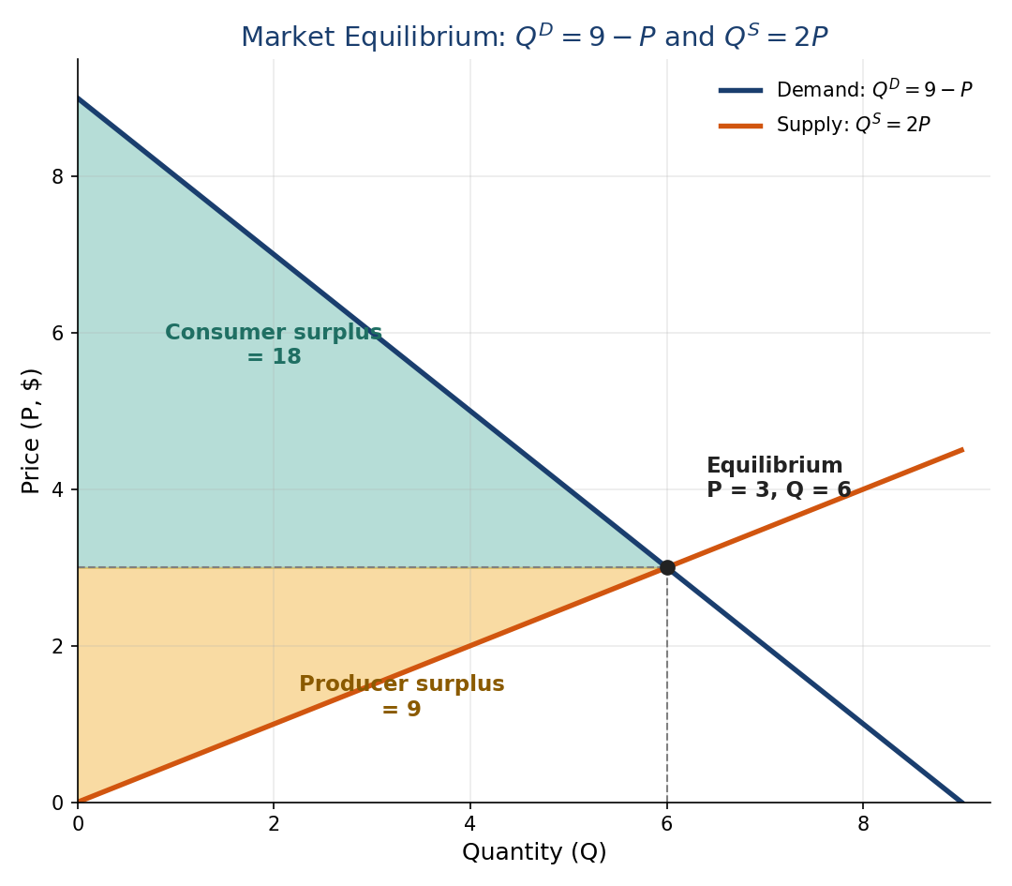
- The consumer surplus is the area between the demand curve and the price (triangle area) (9-3)*(6-0)/2=18
- The producer surplus is the area between the supply curve and the price (triangle area) (3-0)*(6-0)/2=9
- The total social welfare is defined as the sum of consumer and producer surplus.
The total social welfare is therefore 18+9=27

